

ATHLYTICS

Pentagummie

ATHLYTICS

SENIOR PROJECT

TEAM: Pentagummies :

Marwan Helali,

Alexandru Andrei,

Adam Ebel,

Jinting Liu,

Tudor Ghenea

Menu

**1. OVERVIEW 1**

**2. USUER MANUAL 2**

**3.** **TECHNICAL MANUAL 8**

**4. PROJECT RETROSPETIVE**  **14**



ATHLYTICS

Pentagummie

1.Overview

1.Overview

### About Project:

ATHLYTICS is a web-based program for Lindenwood University athletic coaches and student athletes that helps streamline workout assigning. This is the senior project named ATHLYTICS, works for coaches and students. The purpose of the project is helping the coach to train and schedule student in a more effective way. ATHLYTICS provides serveries of on the calendar page, creating workout sheet for coach, sign them for students. Our project leads the coach to save time on mange the team student and workout sheet This program allows students and coaches to register as coaches or students. The students will have to choose which sports team they belong to when registering ie. Men’s Soccer, Women’s Track and Field.

ATHLYTICS is used by the student athletes to view their team specific workout(s) for the day. ATHLYTICS also includes the coaches’ specific functionality like being able to create workouts by creating multiple lifts, assigning reps, assigning weights, scheduling the workouts by day or even by hour, assigning the workouts to the



ATHLYTICS

Pentagummie

[Company Name]

### About Us:

ATHLYTICS was created by the development team Pentagummies; members include Marwan Helali, Alexandru Andrei, Adam Ebel, Jinting Liu, Tudor Ghenea. Following the Marwan’s leading, each of team member did the project well in their respected roles. Alex being the main database programmer. Adam mitigating between managing and the team, calendar functionality programmer, and tester, Tudor mitigating between client and team, home page GUI programmer , tester . Jining being in charge of documentation, minor GUI, presentation/interactive prototype .



2.User Manual

ATHLYTICS

**2. User Manual**

2.USER MANUAL

1. Describe the run and utilize the project
   1. Installation: Since ATHLYTICS is a web-based program the user just has to visit the website and sign up using their Lindenwood email address. (Seen below) <https://athlytics5g.firebaseapp.com/>

* 1. To sign up from the home page the user should can either click the “Get Started” button which brings a new user to the signup page (Seen below) where the user will be prompted for their full name, Lindenwood email a password as well as a selection if the user is a coach or student.

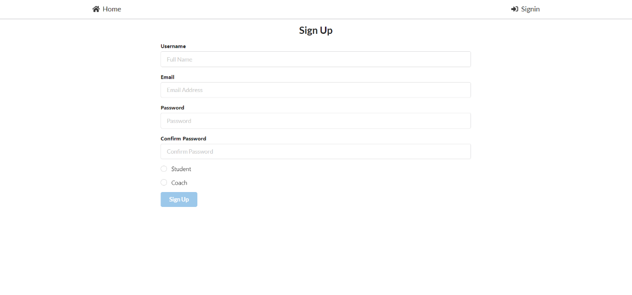

In the case that the student option is selected a drop down will appear for the student to choose which sport he/she belongs to.

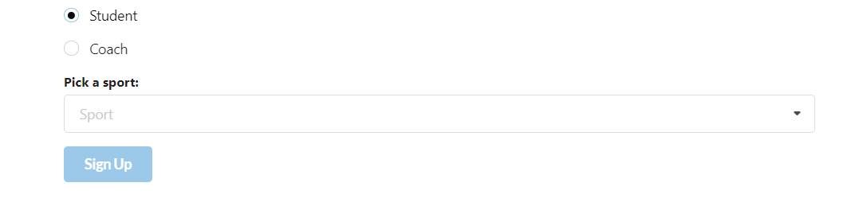

In the case that the coach option is selected another bar appears asking for the “Secret Seed” which is provided by the main admin.

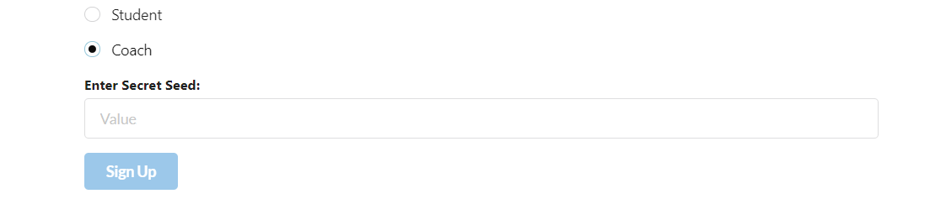

* 1. Once you press the Sign-Up button you will be sent a verification email, with a link that will verify your account, automatically. If you do not receive an email within a few minutes direct yourself to the “Account” link located in the top navigation bar. A “send confirmation E-mail” button will manually send a verification email. The instructions are on the screen to manually send a verification email.

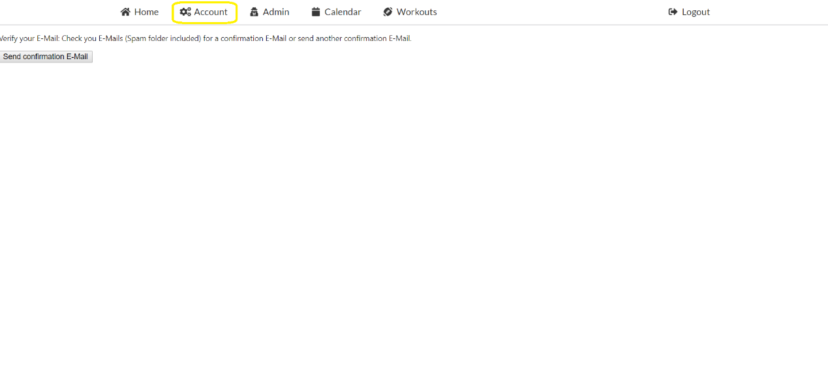

If you are a student, congratulations you have successfully singed up for ATHLYTICS, and as a student you will regularly use the workout link in the navigation bar see the workout your coach gives you for the days to follow.

* 1. Creating workouts. As a coach your job has yet to begin, now comes creating workouts. First clicking the calendar link in the navigation bar will send you to the calendar view.

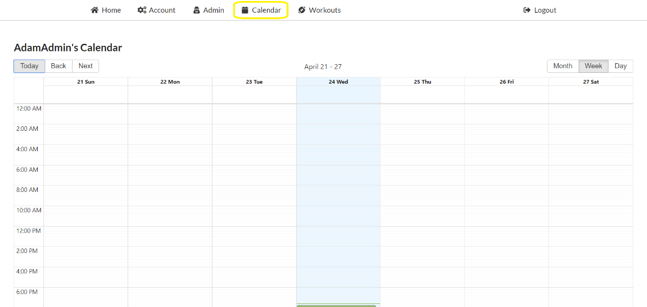

To create a workout, you will need to click and drag on the selected time for the workout, which will bring up a window. This is where you get to name, select the team that the workout is going to be applied too as well as entering in lifts, reps, and weights for the workouts.

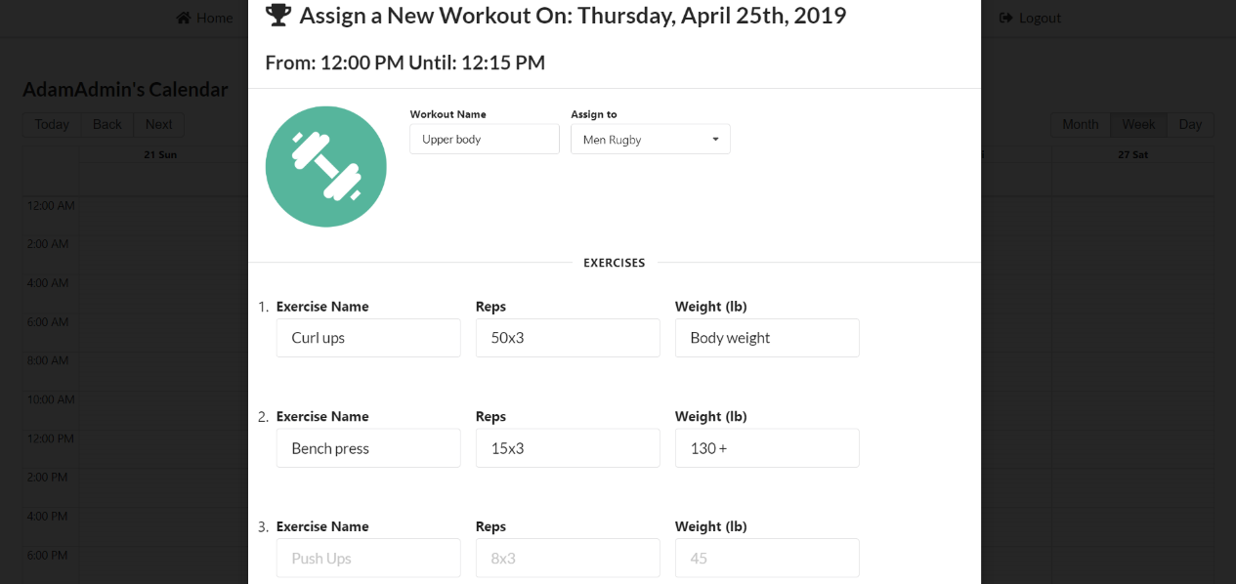

* 1. Once you confirm the workout you can see all the workouts you made under the workout link in the navigation bar.

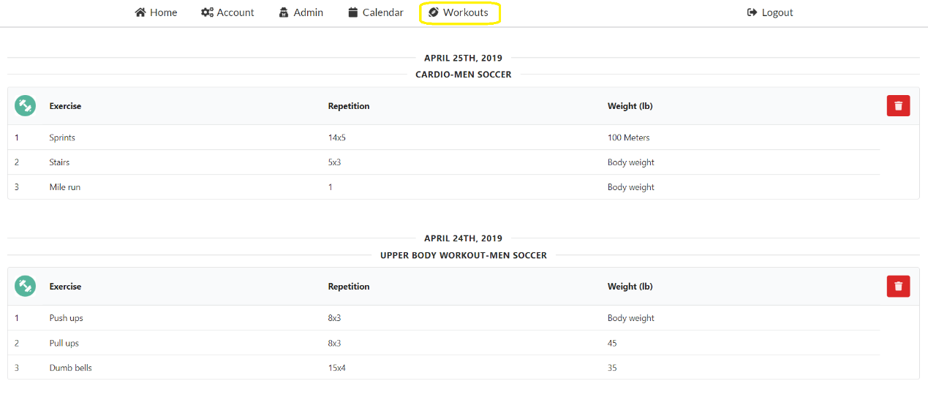

* 1. To delete previously made workouts. From the workout screen (shown above) you only need to press the red button on the left side for the workout you wish to be deleted.
  2. Resetting passwords: To reset a password you must select the “Forgot Password” button at the sign in page. This will bring up a screen that prompts you for your email address. Once you do and press the “Reset My Password” button an email will be sent to the email you have put in. This email will contain a link that will confirm the password change. From there follow the instructions on the email.

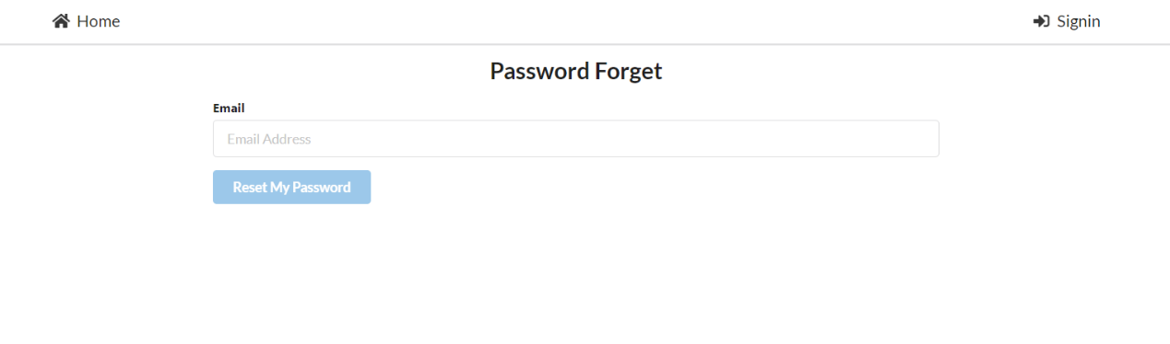

* 1. Changing passwords: Both coaches and students can change their own passwords whenever they wish. In order to do this, you will have to go to the Account link in the navigation bar.

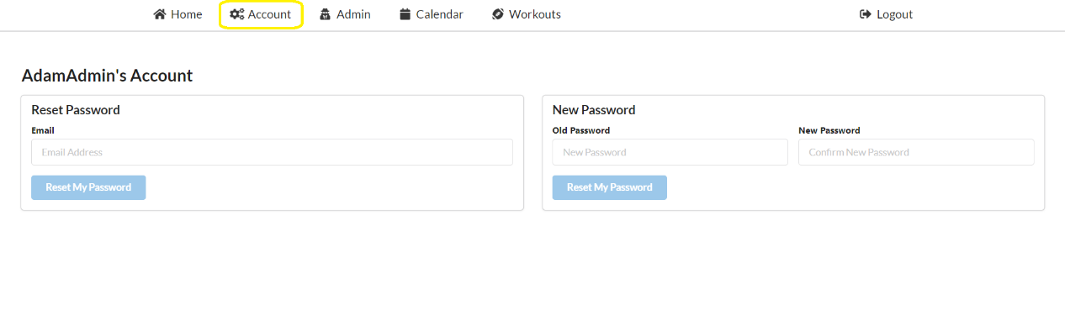

You can reset passwords in 2 different ways, either by using your registered email address or the new password selection.

Both ways will send you verification emails, containing a confirmation link, and instructions.

* 1. Sending Password resets: As a coach you have the ability to send password resets to other accounts. To do this you need to go to the admin page and select the details of the account you wish to send a password reset.

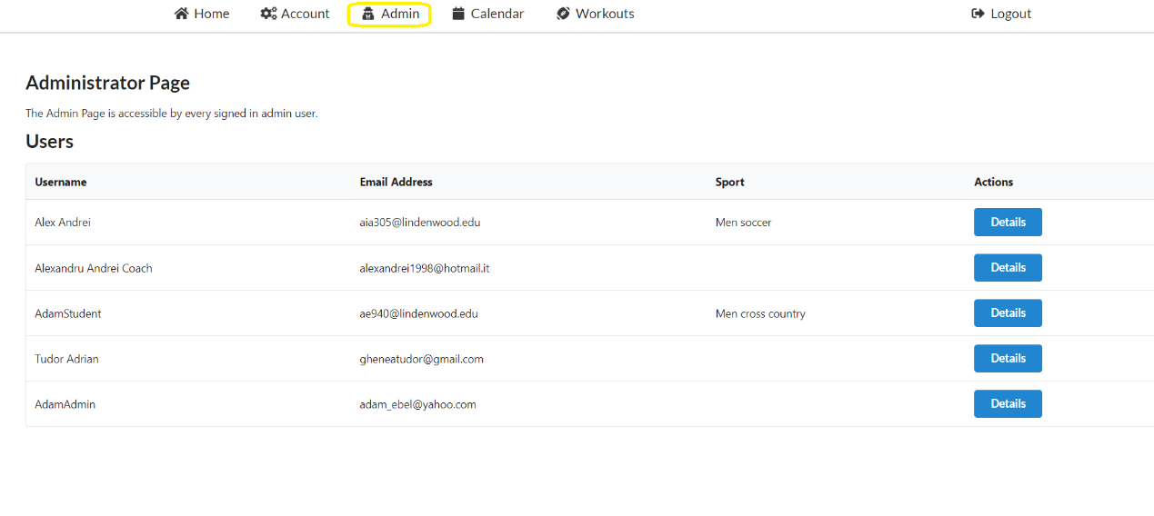

Once you select the account you wish to send a password reset another screen shows up giving you more information about the user as well as the button that allows you to send the password reset.

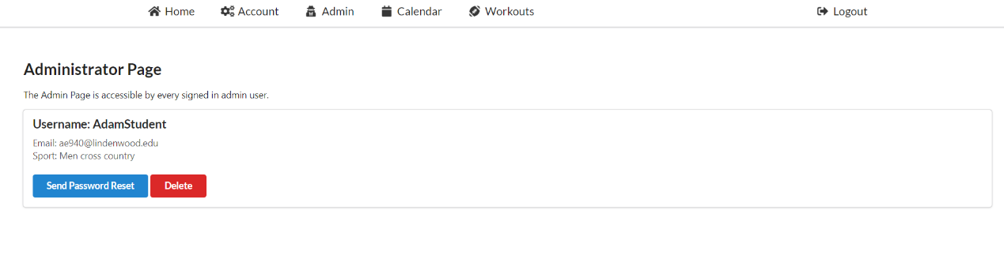

* 1. Deleting users: As a coach you have the power to delete different users from ATHLYTICS. In order to do this, you go to the Admin page and select the details of the account you wish to delete.



Once you select the account you wish to delete another screen shows up giving you more information about the user as well as the button that allows you to delete the user form ATHLYTICS.





ATHLYTICS

Pentagummie

3. Technical Manual

1. TECHNICAL MANUAL

1.Project’s Implementation

* **Coding practices:** 
  + Camel Case naming conventions for variables
  + Used lint that formats code and indentations to look more uniform
  + Terms:
    - Workout – to talk about a more than one exercises, a group of exercises.
    - Exercise – the particular movement/lift to be done.
    - Sets – the amount/times required to be finished with a particular exercise
* **SRC Directory:**
  + Components
    - Account
      * index.js – creates the account page of whomever is logged in. Contains both resetting passwords and resetting email addresses from the account page.
    - Admin
      * index.js – creates the admin page for the current admin
    - App
      * index.js – creates the blank slate of a window that the other components are rendered into
    - Calendar
      * index.js – creates the calendar that is used, also the functionality of the calendar
    - Firebase
      * index.js – exports the function
      * context.js – creates an authorised user context
      * firebase.js – firebase configuration and database setup
    - Home
      * index.js – creates the landing page that prompts the user to sign in or get started with signing up to Athlyitics
      * logoNobackground.png – the Athlytics logo without a background
    - Navigation
      * logo.jpg – the Lindenwood logo
      * favicon.png – a smaller icon of the Athlytics logo without a background
      * index.js – creates the navigation bar, linking other pages together
    - PasswordChange
      * index.js – creates the component for a user to change their own password. Talks to the database to change the password after submitting the new password
    - PasswordForget
      * index.js – creates the component so a user may submit an email for a password reset
    - Session
      * content.js – exports the session
      * index.js – exports the higher order authentications
      * withAuthentication.js – creates the session with the authentication
      * withAuthorisation.js – creates the session with the email authorisation process
      * withEmailVerification.js – creates the session with the email verification process finished
    - SignIn
      * index.js – creates the component for signing up and the functions of the signing in component
    - SignOut
      * index.js – creates the components to sign out and the functions of the component
    - SignUp
      * index.js – creates a user or admin to be added to the database. Checks if the new user is already in the database, and which team the user is apart of. Also checks if the admin knows the secret code in order to sign up as an admin.
    - Users
      * index.js – exports the userList and userItem
      * UserItem.js – displayed the user info
      * UserList.js – puts user items together
    - Workouts
      * index.js – creates the workout component, used to take inputs from the admin and then send the inputs to the database
  + Constants
    - roles.js – Exports “admin” coaches
    - routs.js – Exports constructors
  + img – a file of assorted images used in the program
  + index.css – the cascading style sheet that is used to format the project
  + index.js – creates the basic white page to apply components
  + serviceWorker.js - This lets the app load faster on subsequent visits in production, and gives it offline capabilities. However, it also means that developers (and users) will only see deployed updates on subsequent visits to a page, after all the existing tabs open on the page have been closed, since previously cached resources are updated in the background.

1.2 E/R diagram

**Workouts**

ID (accessor)

Workout Name

Start Time

End Time

Sport

Exercises

UIDS-list

**Exercises**

Exercise name

Set

Weights

**Users**

ID (accessor)

Email

Roles

Sport

Username

But Firebase is a nonrelational database, meaning that there are no relations such that we can make a correct E/R diagram

**1.3 Use Case Diagram**

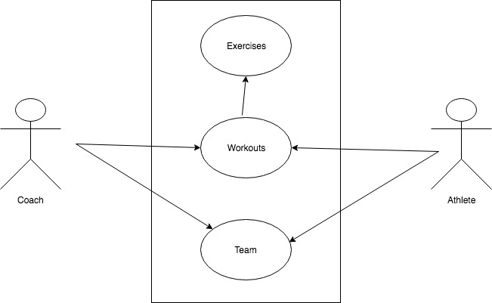

1. **Installation to continue development** 
   * 1. Go to the website: React.js.org
     2. Click on the get started and then follow the instruction on website.(make sure you get the right version of npm)
     3. Import the react calendar using the command line “npm install react-calendar” in the same folder as the “npm install” done in the previous step
     4. Open the GitHub at <https://github.com/Marwan01/Athlytics>
     5. Clone or download to the same folder where react has been installed.
     6. Open in your preferred way and get coding.
     7. Run in cmd” npm start”



ATHLYTICS

Pentagummie

4.Retrospective

## Project retrospective

1. what went right with the project

The team members were able to pick up someone else’s slack when needed, everyone seemed calm even close to the end. The use of Firebase made the creation of the database fairly simple and allowed the incredibly easy implementation of admin accounts and user accounts that passwords are also naturally encrypted ensuring network safety.

2. what went wrong with the project

The project scope was large and at first the team thought we could handle it, underestimating how large the scope really was.

Client kept adding more features onto the project thus making the project scope even larger.

Illnesses, personal problems causing some features to not be completed and implemented on time.

Changing between Material-UI to Semantic-UI caused a few hiccups and code to be scrapped.

**3.Lessons we learned**

* 1. Do not rely on your team but, TRUST your team
  2. We learned the React, Material-UI, Semantic-UI, Firebase
  3. Learning GitHub to do group project
  4. Patience on everything, trust the team.

1. Project Timeline

**3.1 MERGING SCHEDULE**

**1/29/2019** – 1st team meeting, met with client for the first time, gathered scope of the project, chose team roles, very basic GUI ideas, very basic database structure ideas. Concluded that we should use an agile development style.

**2/4/2019** – 2nd team meeting, met with client. Presented the most basic hand drawn GUI, led to more formalized GUI. Gathered more specific functionalities for the project. Project contract signed

**2/6/2019** – 3rd team meeting, very simple E/R diagrams. Focused on how the back end would be utilized, which tables are needed, how the front end of the project would integrate a GUI and functionality. Spoke how the two would communicate. Picked languages and development practices. (JavaScript, React, Firebase) Mild learning react.

**2/11/2019** – 4th team meeting, picked a team name, prepared for the presentation and made slides for the presentation.

**2/12/2019** – Group presentation

**2/20/19** – 5th team meeting, designed the log in page, the signup page, forgotten password page, dashboard. Development on the database. Brainstormed on the user inputs; calendar functionality, workouts vs exercise. Started seriously learning react more. Chose Material-UI so we focused on that.

**2/27/2019** – 6th Team meeting, Learning react

**3/1/2019** – Started the interactive GUI for presentation

**3/6/2019** – 7th Team meeting, Presentation preparation-design & plan presentation, Finished E/R, Finished Database on paper, finished interactive GUI for presentation.

**3/10/2019** – Chose to scrap the mobile application/ mobile friendly web page, scrap the player card, scrap the student surveys, scrap the up to date graphs and charts to represent physical improvement.

**3/18/2019** – Many logos designed.

**3/19/2019** – Picked logo designs.

**3/20/2019** – 8th Team meeting, first draft of calendar, working on login page.

**3/27/2019** – 9th Team meeting, finalized logo design, finished login/sign-up page, working with database, preparation preparation-status report 1, started to design landing page.

**4/3/2019** – 10th Team meeting, checking status coding questions, changed to Semantic-UI, react tutorial.

**4/10/2019** – 11th Team meeting, worked on calendar page, started part of testing.

**4/11/2019** – More testing and bug fixing, work out component built but not merged.

**4/17/2019** – 12th Team meeting, Preparation for project status report, calendar component implemented but not complete, gathered the documentation and started the user manual/final documentations started.

**4/20/2019** – Pushed a functionality to delete users.

**4/21/2019** – Pushed a bug fix for deleting older unneeded workouts.

**4/23/2019** – Implementation and testing for events on calendar to be seen as different colors for the different teams.

**4/24/2019** –13th Team meeting, merging bug fixes, testing application, fixing a bug where a student would be able to delete a workout.

**4/25/2019** – landing page fixing, repeating front page information was a long-standing bug.

**4/26/2019** – Documentation gathering. Documentation workload split over team

**4/30/2019** – Consolidating documentations of the team. Updated burndown chart.

**5/1/2019** – 14th Team meeting. Finished and finalized the documentation, testing, development.

**3.2 Burn down Chart**

### 4.project retrospective

If the team would have done this project over with what we know now there would be a few changes, most notably the team would be a bit quicker to start coding and thus making progression quicker, making milestones more easily and on time.

Another thing the team would have done differently is discussing the scope earlier. The scope would have been talked down a earlier on letting us focus on necessary elements and functions of the program, allowing us more time during the middle sprints to add more features, thus delivering a more expansive product.

Quite possibly longer meetings could be useful, where we would after we discussed what to do, get some of the laundry list of things we still needed to finish finished. This again would have moved the project along and progressed at a quicker pace that what had happened.

Utilizing more team meetings is a viable option as well, originally we used these team meetings to provide the team with status updates every week, but coupling this with the previous altercation mentioned we would meet more 2 days out of the week or more, and progress the project along beside each other rather than individual pieces only to come in a weekly meeting to show what we have gotten done.